**Certificates of Deposit in U.S banking sector**

Certificates of Deposit (CDs) are a popular savings product offered by banks in the U.S., providing a safe way for individuals to save money and earn interest.

**What is a Certificate of Deposit (CD)?**

* **Definition**: A CD is a savings account with a fixed interest rate and fixed date of withdrawal, known as the maturity date.
* **Interest Rate**: Generally higher than regular savings accounts due to the fixed term.
* **Terms**: Vary from a few months to several years.
* **Penalty for Early Withdrawal**: Withdrawals before the maturity date usually incur a penalty.

**Benefits of CDs**

* **Safety**: FDIC-insured up to $250,000 per depositor, per insured bank.
* **Predictable Returns**: Fixed interest rates provide certainty of returns.
* **Variety of Terms**: Flexibility to choose terms that suit individual financial goals.
* **Laddering Strategy**: Investors can create a CD ladder to manage liquidity and interest rate risk.

**Current Trends and Statistics**

1. **Interest Rates**: Interest rates for CDs fluctuate based on Federal Reserve policy and economic conditions. As of 2023, average rates for 1-year CDs are around 1.50%, while 5-year CDs offer about 2.50%.
2. **Popularity**: CDs remain a favored choice for conservative investors, particularly during periods of economic uncertainty. In 2023, there was a notable increase in CD deposits as investors sought stable returns amid market volatility.
3. **Market Size**: The total value of CD deposits in U.S. banks was approximately $1.2 trillion in 2023.

**Types of CDs**

1. **Traditional CDs**:
   * Offer a fixed rate and term with penalties for early withdrawal.
2. **Jumbo CDs**:
   * Require larger minimum deposits, typically $100,000 or more, and often offer higher interest rates.
3. **Bump-Up CDs**:
   * Allow for a one-time increase in the interest rate if rates go up during the term.
4. **Step-Up CDs**:
   * Feature predetermined interest rate increases at specific intervals during the term.
5. **No-Penalty CDs**:
   * Allow for early withdrawal without penalties, usually at the cost of a slightly lower interest rate.
6. **Brokered CDs**:
   * Purchased through brokerage firms rather than directly from banks. They can sometimes offer higher rates but may have different terms and conditions.

**Benefits of CDs**

1. **Safety**:
   * CDs are considered low-risk investments due to their fixed returns and FDIC insurance.
2. **Predictable Returns**:
   * The fixed interest rate ensures that investors know exactly how much they will earn by the end of the term.
3. **Diverse Options**:
   * Various types and terms allow investors to choose CDs that best match their financial goals and liquidity needs.

**Drawbacks of CDs**

1. **Lower Returns Compared to Other Investments**:
   * The safety of CDs often comes at the cost of lower returns compared to stocks, bonds, or mutual funds.
2. **Inflation Risk**:
   * Fixed returns mean that if inflation rates rise significantly, the real value of the interest earned may decrease.
3. **Limited Liquidity**:
   * Funds are locked in for the term of the CD, and accessing them early can result in penalties.

**Current Trends and Considerations**

* **Interest Rate Environment**: The interest rates offered on CDs are influenced by the broader economic environment and the Federal Reserve's monetary policy.
* **Laddering Strategy**: Investors often use a laddering strategy, purchasing multiple CDs with staggered maturity dates to balance liquidity and returns.
* **Online Banks**: Online-only banks often offer higher interest rates on CDs due to lower overhead costs compared to traditional brick-and-mortar banks.

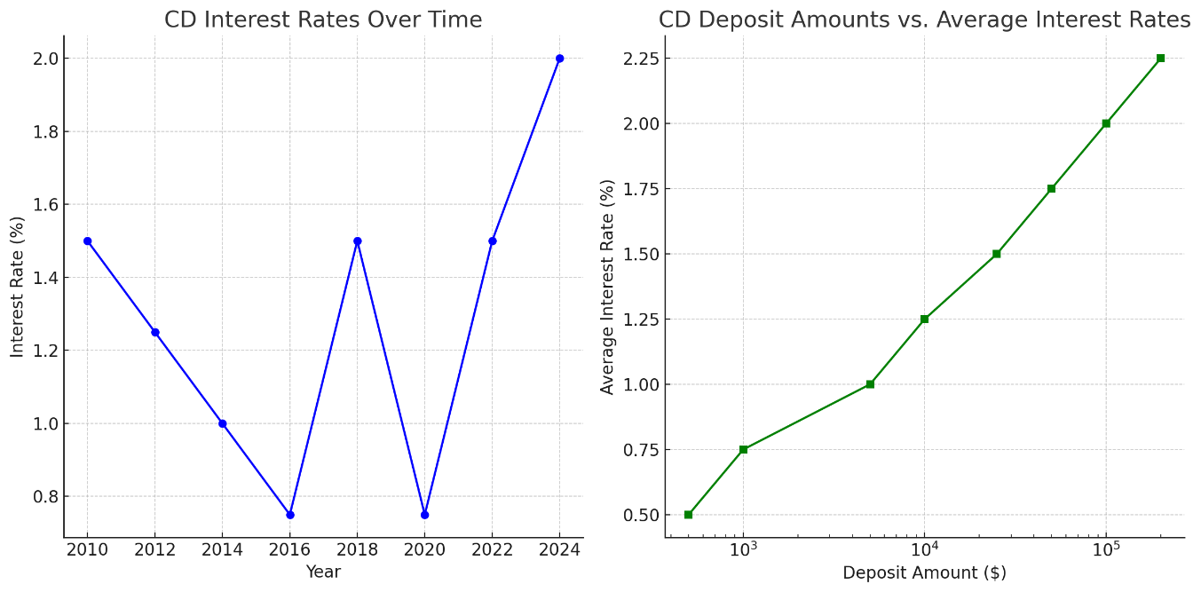

**CD Interest Rates Over Time**

This graph shows the trend in CD interest rates from 2010 to 2024. The interest rates have fluctuated over the years, reflecting changes in the broader economic environment and monetary policy decisions:

* **2010-2016**: A general decline in interest rates.
* **2018**: A notable increase, reflecting a period of rising rates.
* **2020**: A dip due to economic factors, such as the COVID-19 pandemic.
* **2022-2024**: A steady increase as the economy recovers and interest rates rise.

**2. CD Deposit Amounts vs. Average Interest Rates**

This graph shows the relationship between different deposit amounts and the average interest rates offered for CDs:

* Higher deposit amounts tend to offer higher average interest rates.
* Jumbo CDs (with larger deposits, typically $100,000 or more) offer significantly better rates.

These visuals highlight how interest rates for CDs have evolved and how deposit amounts can influence the interest rates offered by financial institutions. ​